Lab-56:
Assignment 1: Creating and Using Stored Procedures:
In this assignment, we need to create a stored procedure to manage the employee records in a database.
1. create a companyDB database first. Create a table named Employees which will have fields as EmployeeID(primary key), FirstName, LastName, Department and Salary.
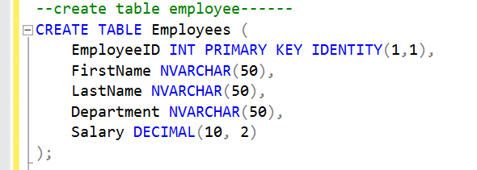
2. insert records into it:
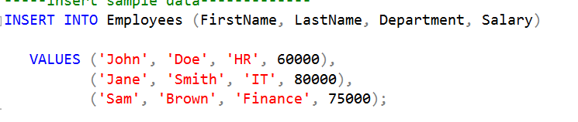
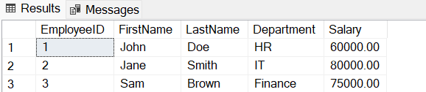

3. create a stored procedure to add a new employee record whenever we execute this store procedure. The procedure name will be AddEmployee , it will take parameters as: @FirstName NVARCHAR(50), @LastName NVARCHAR(50), @Department NVARCHAR(50), @Salary DECIMAL(10, 2) and a insert command to insert a record in an Employee table.
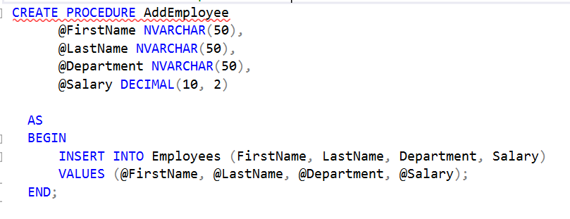
4. to execute the stored procedure we can write a query as:
This will insert a new record into a Employee table. This is the output:
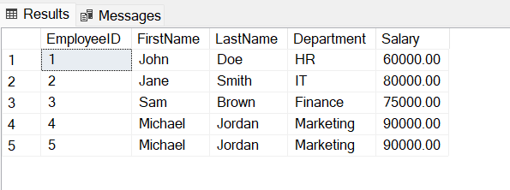

5. create a stored procedure to retrieve the employees by the department name.
Create a procedure name GetEmployeesByDepartment and take a parameter as @Department NVARCHAR(50) to provide the department name.
Give a sql command to retrieve the employee record based upon the entered department name.
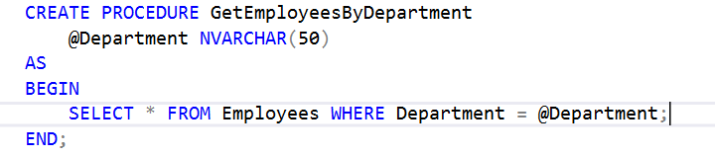
6. execute the stored procedure by giving a department name.

This will execute the employee records which have IT as a department.
